# RandomBiLSTM Experiment result

Word Embedding:

Elmo, 1024d

Sentence embedding method:

Refer to paper:

*<<* *No Training Required - Exploring Random Encoders for Sentence Classification >>* (Chapter 3.1.2 RANDOM LSTMS)

*<<Supervised Learning of Universal Sentence Representations from Natural Language Inference Data>>* (Chapter 3.2.2 BiLSTM with mean/max pooling)

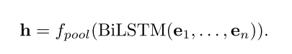

$f_{pool}$ is a pooling method. In this experiment, we use **max pooling**.

A figure explanation:

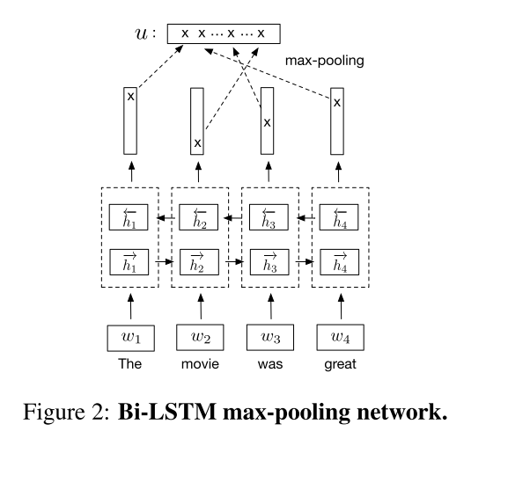

Detailed explanation about RandomBiLSTM in our experiment:

Weight initialized like paper suggested, hidden size of LSTM set to 499( this is also sentence length of reviews), n_dimension=1024

#word embedding dimension

out_s©hape=128

**Classifier:** MLP, 2 hidden layers with 150 neurons in each layer, optimizer: adam

**Note:** I keep the reviews in train set only when review length<500. Trainset size is 26.5GB, needs text is 1.2GB.

It’s actually better than WR and tf-idf !